

**ASSIGNMENT 4 REPORT**

Name: MUHAMMAD AYAZ HASAN

Roll No: 20K-1044

Section: BS-SE (5A)

Subject: Software Construction & Development

Date of Submission: 27/11/2022

**Description of Program**

This Program is develop to calculate the complex physics equation for Kinetic Energy(KE) and Electrical Potential Energy(EPE) ;

Formula for KE & EPE is:



**Multithreading using Java Executable-Framework**

Using Executable framework 6 thread is setup and allocate all the task to these threads.



* Now input the all the values for solving equation is given through constructor and pass it to ExecutorSevice

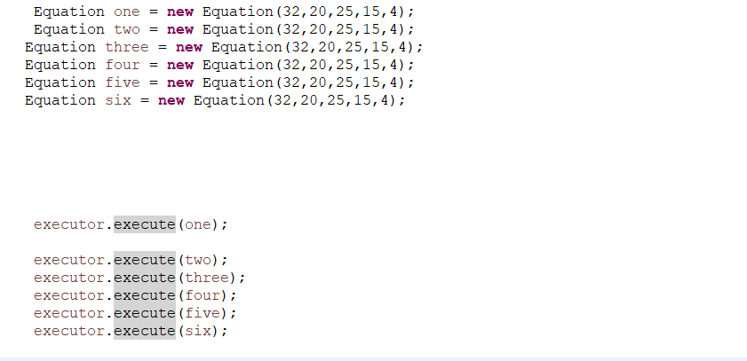

* Values include (mass, velocity, charge, distance between two object:



* Runnable function is used to calculate the final result of the Equation

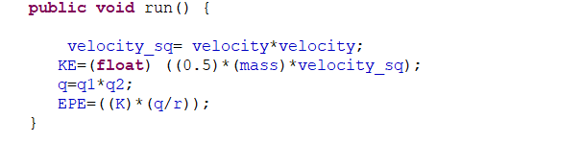

* While the individual calculation of the components pass to avaialble threads

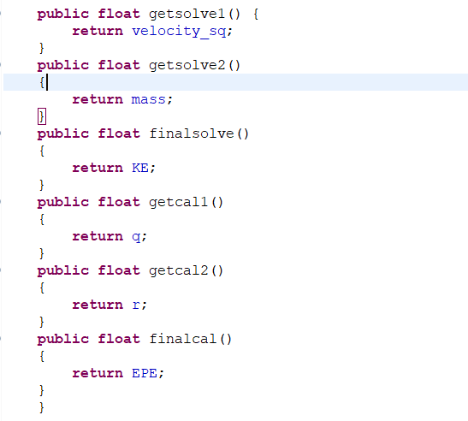

* The output is as follows:

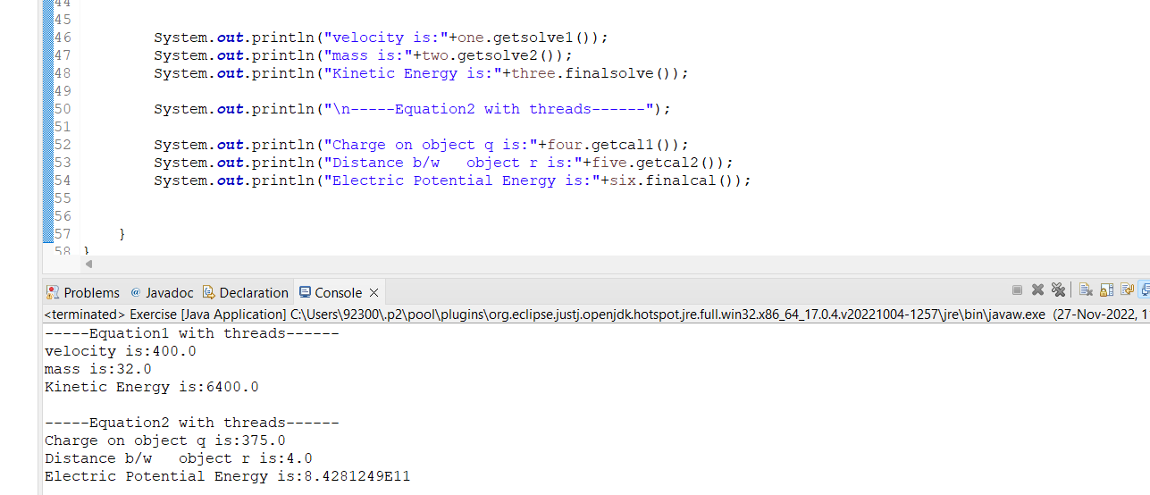

* The executor Service is shutdown when thread are no more in use in order to save resources



_____________________________________________________________________________________